Braden Whitcher

CS-330

Dr. Brian Holbert

5 November 2024

Milestone One

A 2D scene that I chose to replicate into a 3D scene is a picture that I took of my desk with some items on top. Here are the images that I took:

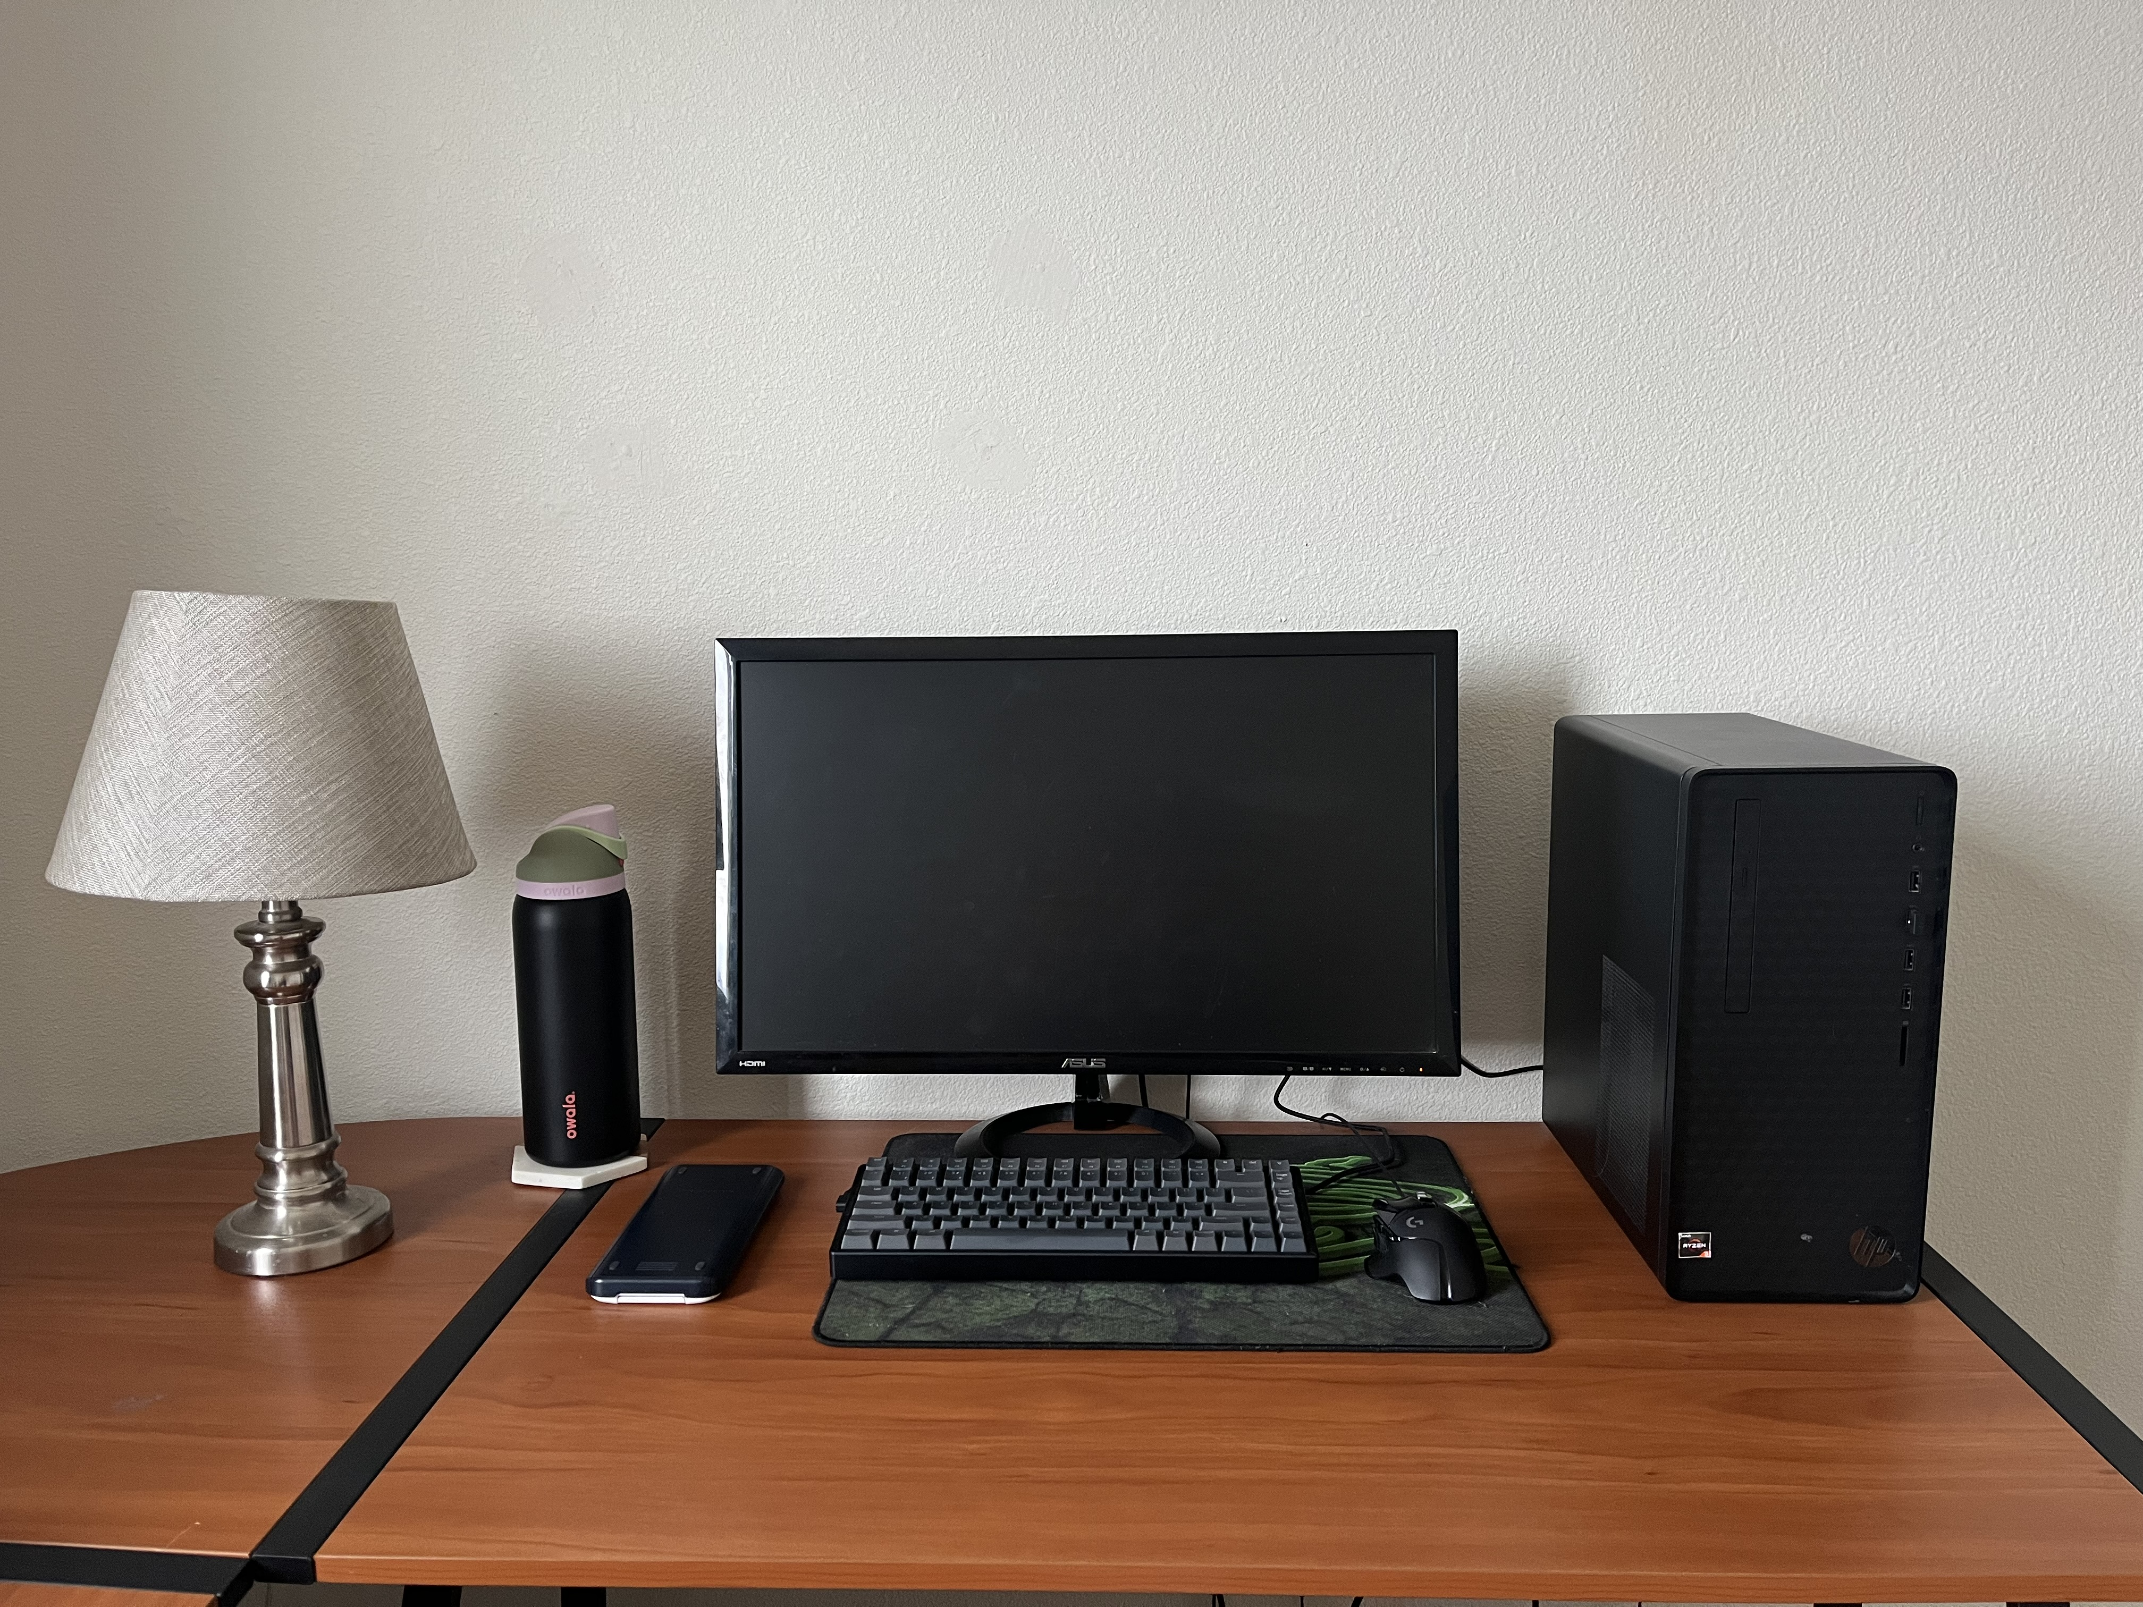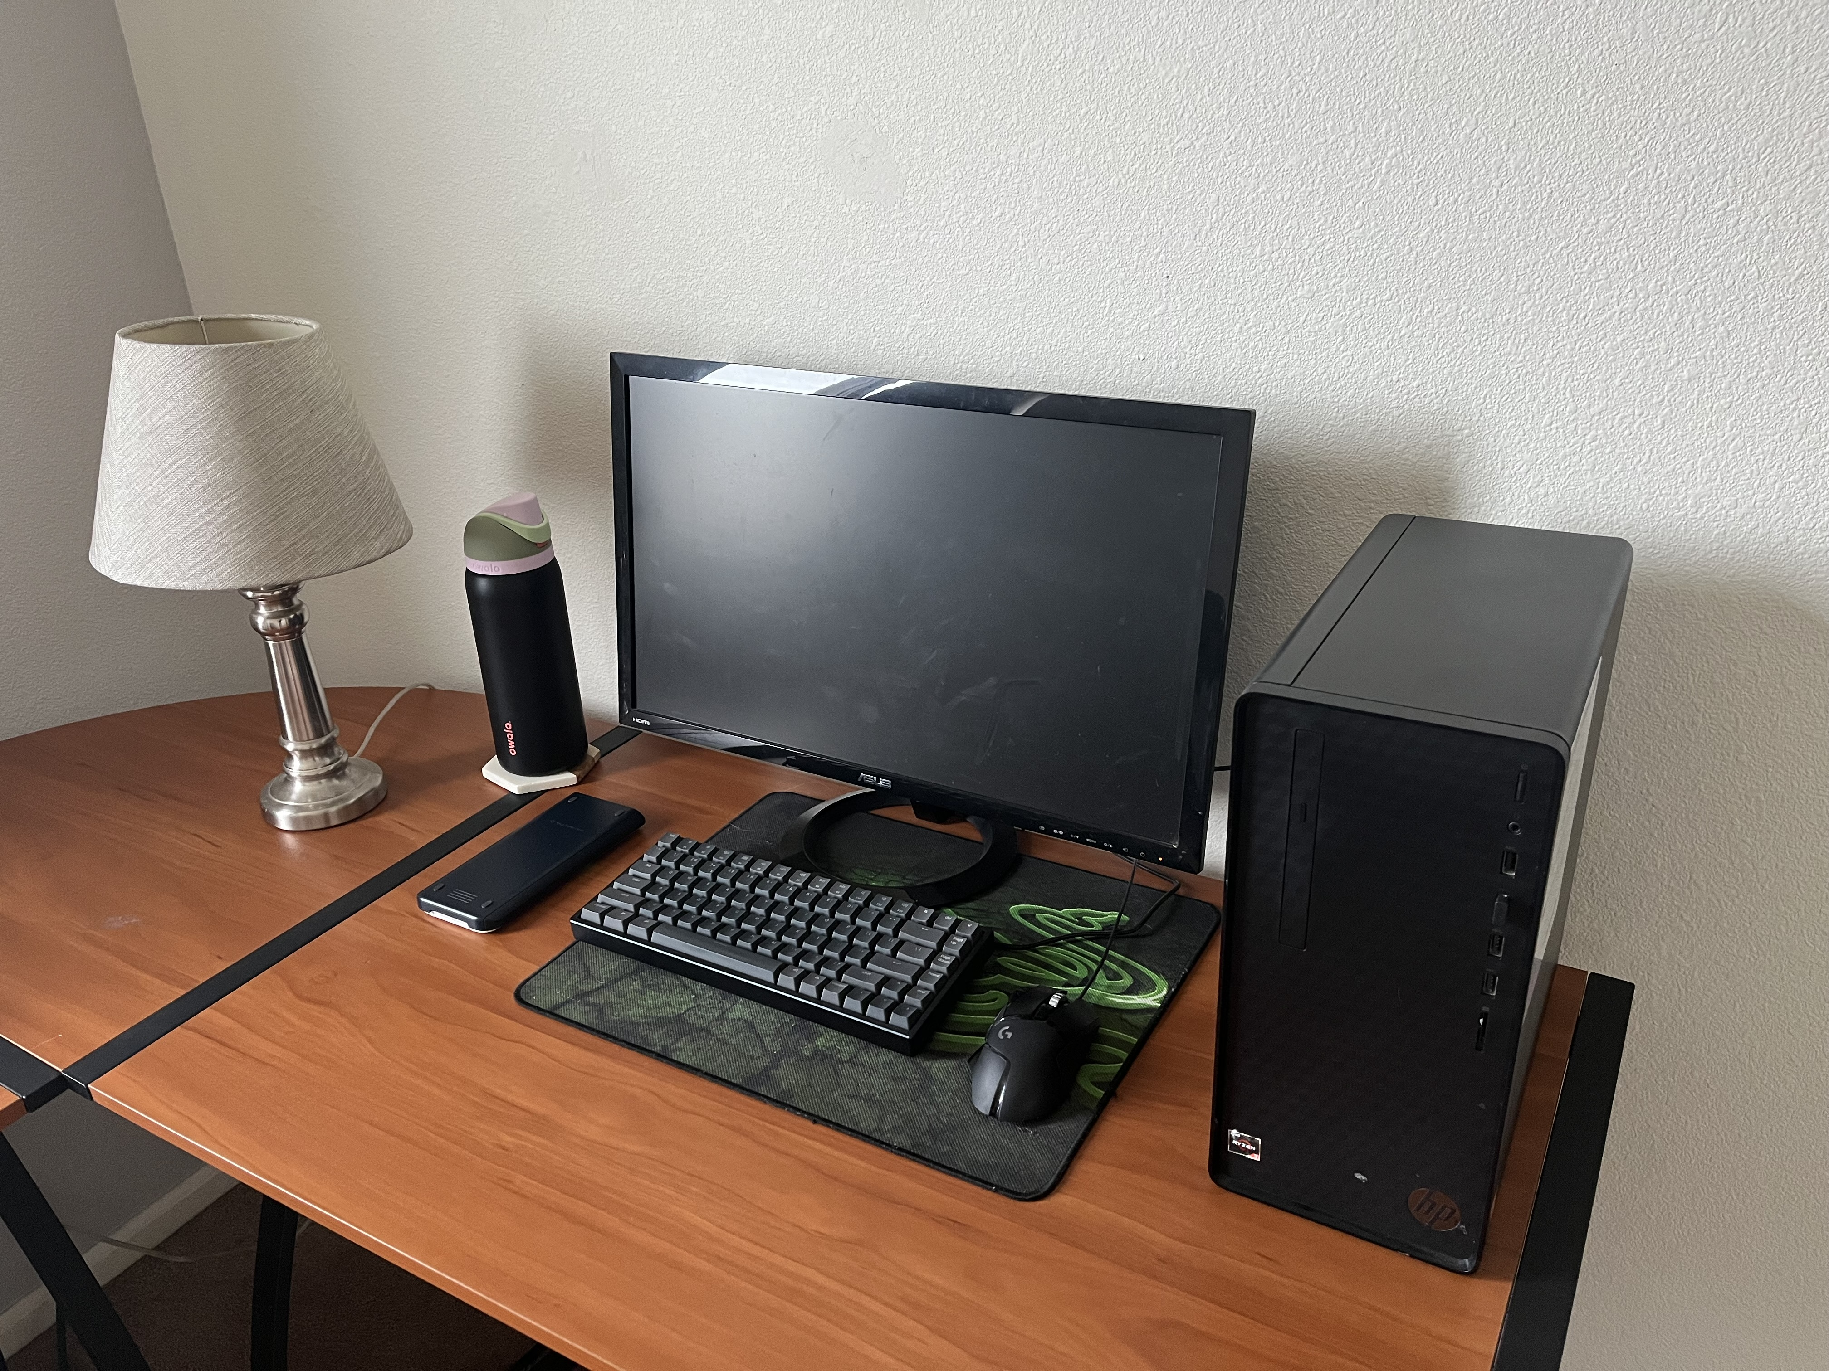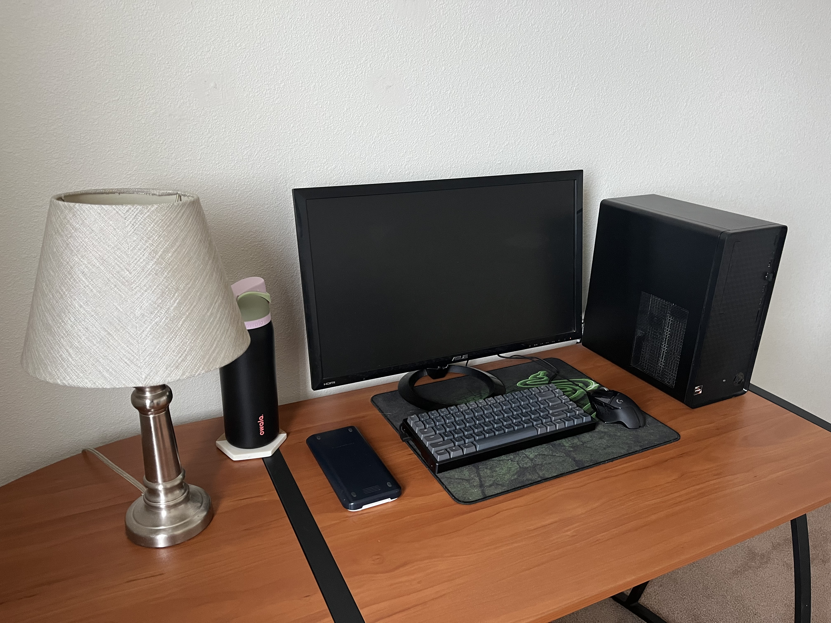The reason why I chose my desk is because there is a wide range of shapes that can be used and put into practice. Here is the list of items I will be replicating into a 3D scene: top of the desk, lamp, water bottle, coaster, calculator, mousepad, monitor, keyboard, mouse, and desktop PC. These items are a good choice for my work because only a few of them require the same shape to be used, the rest are unique in the type of shape that I will have to use.

The top of the desk will be a plane, which is what is going to ground the rest of the items. For the lamp, I am going to use a thick torus for the bottom, a tapered cylinder that will sit on top, a thin cylinder for the body, and another tapered cylinder for the lampshade. As for the design of the body of the lamp, I could use a torus for each ridge that comes out, but I might just make it a smooth cylinder for the sake that this is my first time ever creating 3D objects with OpenGL. The coaster is a bit tricky since it is in the shape of a hexagon, I could use a flattened cylinder and adjust the number of sides on it to make it in the shape of a hexagon. The water bottle, which is sitting on top of the coaster, will have a cylinder that replicates the body. The top will have two, more flattened, cylinders that replicate the pink and green color with a prism that sits on top. The prism will replicate the angle that is on the cap of the water bottle.

The calculator will be made with a box, one to represent the white part and another for the blue case that slides on top. The mousepad will be replicated using a flattened box. The keyboard will also be a flattened box, and the keys will be boxes as well. The bottom of the stand of the monitor will be a flattened torus, the stem that leads to the screen will be a thin box to make a rectangle, and the screen itself will also be a box. The mouse will be replicated by using a half sphere since the bottom is flat. When I first make it, the only detail I will include will be the scroll wheel, which can be replicated by using a torus that is rotated 180 degrees on the x-axis.

After analyzing the different types of shapes that will be used for each object, I believe my choices for the shapes make sense because they are very similar to the shape of the actual object. The only object that I feel will be very difficult to replicate will be the cap of the water bottle, since the angle isn’t a straight line, it kind of tapers down exponentially. Other than that, I think the shapes I chose are achievable by someone using OpenGL for the first time.